NI Measurement Plug-In Converter

Contents

Overview 2

Related Links 2

Software Requirements 2

Installation 2

Note: 2

Supported Datatypes 3

Supported Instrument Drivers 3

Prerequisites 3

Limitations 3

Known Issues 4

How to convert measurements using NI Measurement Plug-In Converter? 4

Additional Steps for VISA instruments 5

Event Logger 5

# Overview

NI Measurement Plug-In Converter converts Python measurements to measurement plug-ins.

# Related Links

* [InstrumentStudio Pro Manual](https://www.ni.com/docs/en-US/bundle/measurementplugins/page/measurement-plugins.html)
* [TestStand Manual](https://www.ni.com/docs/en-US/bundle/teststand/page/user-manual-welcome.html)

# Software Requirements

[Python 3.8.5](https://www.python.org/downloads/release/python-385/)

|  |  |
| --- | --- |
| **Python Packages** | **Version Required** |
| Mako | 1.2.1 or above |
| click | 8.1.3 or above |
| astor | 0.8.1 or above |
| pydantic | 2.8.2 or above |
| ni-measurement-ui-creator | 1.0.0.dev5 or above |

|  |  |
| --- | --- |
| NI Packages | Version Required |
| NI InstrumentStudio Pro | 2024 Q3 or above (Optional) |
| NI TestStand | 2023 Q4 or above (Optional) |

# Installation

* Run the `install.bat` file by double clicking it.

## Note:

* Require Internet access to install the external dependencies of NI Measurement Plug-In Converter.

# Supported Datatypes

* int
* float
* str
* bool
* List[int]
* List[float]
* List[str]
* List[bool]

# Supported Instrument Drivers

* NI-DCPower
* NI-DMM
* NI-Digital
* NI-FGEN
* NI-Scope
* NI-Switch
* NI-VISA

# Prerequisites

The Python measurement should

* Contain a measurement function which should
  + Contain a return value.
  + Have properly type hinted inputs and outputs.
  + Use one of the supported drivers.
* Initialize the instrument driver's session inside the measurement function.
* A driver’s session must be initialized using context manager `with` in Python.

# Limitations

* Conversion of measurement class is not supported.
* Multiple instances of the same instrument driver’s session are not supported.
* Multiple instances of multiple instrument driver's session are not supported.
* Measurement UI created by the tool doesn’t support List of strings and List of booleans.

# Known Issues

* Measurements which didn’t follow the prerequisites will not be converted correctly.
* For NI-VISA a few more additional steps must be followed. Refer Additional Steps for VISA instruments

# How to convert measurements using NI Measurement Plug-In Converter?

* Install the NI Measurement Plug-In Converter. Refer Installation.
* Open Command Prompt.
* Run the below command,
  + ni-measurement-plugin-converter --display-name <Display Name> --measurement-file-dir <Measurement file directory> --function <Measurement function name> --output-dir <Output directory>

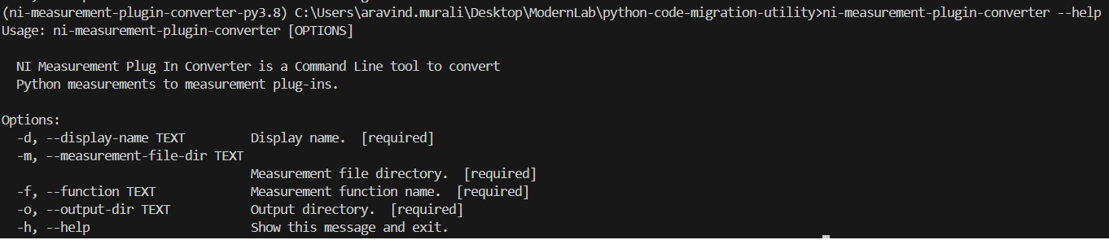

* Modify the CLI arguments with appropriate values.
* Measurement plug-in will be created at the Output directory.

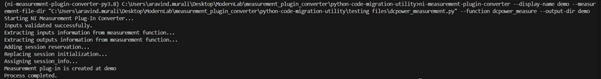

# Additional Steps for VISA instruments

For VISA instruments, the session_constructor and INSTRUMENT_TYPE_NI_VISA must be updated with its appropriate values.

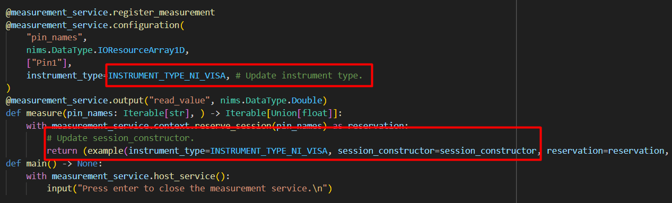

* For session_constructor, create SessionConstructor object of the instrument driver used.
* For INSTRUMENT_TYPE_NI_VISA, assign with pin map constant string. This string must be the same defined in pin map.

# Event Logger

* The tool will generate a log once the conversion process is started, documenting all the actions performed by the tool throughout the conversion process.
* Log file can be found at the output directory.
* The log includes the details about any errors encountered during the conversion process.